ServiceUpdater Guide
Installation, Configuration, and Usage

Installation

- Copy the contents of the provided .zip file into a folder (for example, C:\ServiceUpdater).
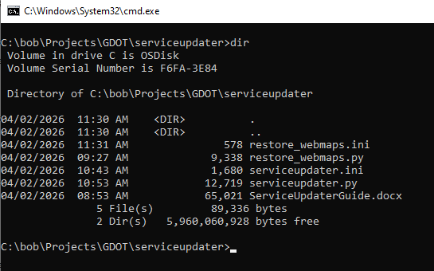

Configuration

- Use a text editor to update serviceupdater.ini for your environment.

[arcgis]
portal_url = your org URL (ex: https://mapps.maps.arcgis.com)
username = your username
password = your password

[urls]
from_url = YOUR-FROM-URL
to_url = YOUR-TO-URL
# this is the portal itemid for the to_url. If the found item has a itemId property it will be set to this value
to_itemid = YOUR-TO-URL-ITEMID

[search]
# two choices available (uncomment only one per run):

# webmap_search_query = type:"Web Map" -- will search for all webmaps, and process those that have the from_url in them
# uses: dry_run, max_matching_webmaps_to_process

# webmap_search_query = id:"YOUR-ItemID-TO-SEARCH-FOR" -- will only search for the webmap with the specified id (useful for testing)
# uses: dry_run, max_matching_webmaps_to_process

webmap_search_query = type:"Web Map"

[run]
# dry_run = true -- will not save any changes to the webmap items, but will log all changes that would have been applied
# dry_run = false -- will apply and save all changes to the webmap items and log them
dry_run = true

# log file will be created here
log_folder = C:\temp

# max_matching_webmaps_to_process = -1 -- set to a positive integer to limit the number of web maps processed,
# or -1 to process all web maps found
max_matching_webmaps_to_process = -1

Usage
IMPORTANT: Create a backup of your web maps before running this script. Esri tech support can advise on this.

- Open Command Prompt.
- Change into the folder where you extracted the zip (the folder that contains serviceupdater.py), for example: cd C:\ServiceUpdater
- Run the script (update the path to python.exe if yours is different): "C:\Program Files\ArcGIS\Pro\bin\Python\envs\arcgispro-py3\python.exe" serviceupdater.py

The serviceupdater script will run. When it finishes, review the log file (in the log_folder you set in serviceupdater.ini) to see what was updated.

Conservative approach:
- Try dry_run = true first and review what it will be changing
- Next try running a limited number of updates (max_matching_webmaps_to_process
- =1) and review (1-?)
- Either
  - continue to run in limited chunks
- or
  - continue to do “all the rest” (max_matching_webmaps_to_process=-1)

Restore_WebMaps Guide
Installation, Configuration, and Usage

This script is only used to restore web map JSON if a ServiceUpdater error is discovered.

Configuration

- Use a text editor to update restore_webmaps.ini for your environment.

[arcgis]
portal_url = your org URL (ex: https://mapps.maps.arcgis.com)
username = your username
password = your password

[restore]
backup_folder = YOUR-BACKUP-FOLDER # e.g. C:\temp\webmap_backups

# all | single
restore_mode = all

# Only used when restore_mode=single
# webmap_id = YOUR-WEB-MAP-ID

# false = log only, do not restore -- true = perform restore
dry_run = false

# processing log is written here (also contains details of restore operations performed, or that would have been performed in dry_run mode)
log_folder = C:\temp\webmap_backups

Usage

IMPORTANT: Create a backup of your web maps before running this script.

- Open Command Prompt.
- Change into the folder where you extracted the zip (the folder that contains restore_webmaps.py), for example: cd C:\ServiceUpdater
- Run the script (update the path to python.exe if yours is different): "C:\Program Files\ArcGIS\Pro\bin\Python\envs\arcgispro-py3\python.exe" restore_webmaps.py

The restore_webmaps script will run. When it finishes, review the log file (in the log_folder you set in restore_webmaps.ini) to confirm what was restored.

